

**Europe and Central Asia (ECA)**

**Integrated ESG standards Program**

**BEYOND the BALANCE SHEET:**

**DISCLOSURE & TRANSPARENCY**

**Training of Trainers (TOT)**

|  |
| --- |
| **Stonework (1)** |

**Three-Webinar Series: June 9, 16 and 23, 2021**

**Time: 13:00 – 16:00 CET (7:00 – 10:00 EST)**

**Venue:** [**ZOOM MEETING LINK**](https://worldbankgroup.zoom.us/j/94148108484?pwd=S3dOYWd6L2h0ekxRWm83clhKZkpldz09)

IN PARTNERSHIP WITH

****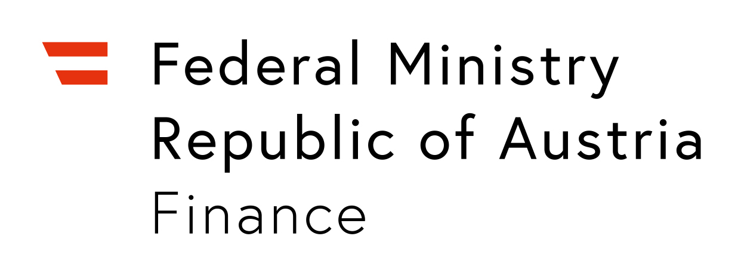

**Disclosure and transparency (D&T)** **are critical for attracting capital and building resilient enterprises in emerging markets.** Transparent corporate reporting, integrating financial and sustainability information, increases trust and confidence for investors and other stakeholders as it provides critical insights into how companies manage their operations and make decisions relevant to pursuing opportunities and managing risks. Disclosure and transparency may also shed light on how companies create different types of long-term value, including contributions to addressing societal crises, such as the current pandemic. Market regulators and stock exchanges play a critical role in encouraging good corporate governance and transparency by developing and promoting sustainability requirements that reflect international best practices adapted to emerging markets and regional priorities.

**This D&T webinar series, developed jointly by the International Finance Corporation (IFC) and UN Sustainable Stock Exchanges Initiative (UN SSE) aims to** help IFC’s partners in Europe and Central Asia to:

1. Understand the international and EU sustainability disclosure landscape.
2. Practice how to prepare and assess annual reports for investors and other stakeholders, integrating financial and sustainability information according to good international practice.
3. Enhance the knowledge base, skills sets and access resources to provide:
   1. Training on sustainability disclosure for companies, banks and boards of directors; and
   2. Policy support on developing ESG reporting guidelines and understanding of green finance for regulators and stock exchanges.

**The Integrated ESG Standards Program** has organized this webinar series to help partner institutions deepen their knowledge of sustainability disclosure and transparency and to build regional capacities to adapt IFC’s award-winning Disclosure and Transparency Toolkit “Beyond the Balance Sheet” resources for consulting and other services in the region.

**Who should attend?**

Participation will be limited to two persons per partner institution. It is expected that partner institutions will develop action plans on services and timelines that are doable for each institution.

**Program details:**

The D&T webinar training series will consist of **three sessions of three hours each,** with peer-to-peer learning exercises and access to one-hour “Ask the Experts” consultation sessions between the weekly sessions.

**Objectives and Agenda schedules for the three D&T webinar sessions are summarized below, followed by IFC Team Bios.**

**Objectives of the D&T Webinar Series:**

* Improve D&T knowledge and deepen understandings of the strategic value and demand for transparent corporate disclosure and reporting practices;
* Develop the capacities to adapt D&T resources and plan training programs, consulting and other services that advance integrated ESG reporting; and
* Share and further develop D&T learning resources to support regional capacity building networks and partnerships.

**AGENDA for D&T Webinar Sessions (3)**

|  |  |
| --- | --- |
| **Wednesday– June 9, 2021** | |
| **07:00 – 07:30** | **Welcome, Orientation and Expectations**   * **Caroline H. Bright**, Regional ESG Advisory Lead for Easter Europe, Central Asia and Latin America * **Ralitza Germanova**, Disclosure and Transparency Program Lead, IFC * **Mary Jo Larson**, Senior Consultant, IFC |
| **07:30 - 08:10** | **MOTIVATION DISCUSSION PANEL**  **How Companies Attract Capital and Build Resilient Enterprises**  Panel Discussion: How do organizations pursue opportunities, manage risks and report on strategic ESG performance to meet international and EU sustainability and disclosure requirements?  **Moderator**: **Vladimir Hrle,** ECA ESG Program  **Panel members: Anne Molyneux, Bistra Boeva, Ralitza Germanova** |
| **08:10 - 08:30** | **EXPERIENTIAL ADULT LEARNING**  **How to engage adult learners?** What are the value-adding features of experiential adult learning? How does an experiential training design motivate, inform and strategically activate adult learners?  **Mary Jo Larson,** Senior Consultant, IFC  **Bistra Boeva,** Professor, member of the IFC Private Sector Advisory Group |
| **08:30 - 09:20** | **GOVERNANCE DISCLOSURE**  **Board Leadership, Structure and Functioning**  What are the key aspects of board leadership, structure and functioning of the board of directors to include in transparent corporate disclosure?  **Anne Molyneux,** Vice Chair, International CG Network, member of IIRC and Director, CS International |
| **09:20 - 09:40** | **Beyond the Balance Sheet**  **Practical Resources on Disclosure and Transparency:** How best to blend IFC’s knowledge tools and online resources with regional D&T guidance and support?  **Mary Jo Larson,** Senior Consultant, IFC  **Ralitza Germanova,** Disclosure and Transparency Program Lead, IFC |
| **09:40 - 09:50** | **Next Steps in Preparation for June 16, 2021**  **Yuliya Holodkova**, CG Officer ECA ESG Program |

**I. “Ask the Expert” Series**

**Activity for June 14, 10-11 am CET**:All participants are invited to sign up for a one-hour session on Corporate Governance Disclosure with Anne Molyneux. [Please sign up for the session by sending an email to Mirjana Djukic at [mdjukic@ifc.org](mailto:mdjukic@ifc.org) by June 11].

|  |  |
| --- | --- |
| **Wednesday – June 16, 2021** | |
| **07:00 - 07:20** | **Welcome and Orientation**  Orientation includes June 9 review and discussion of peer learning assignments.  **Yuliya Holodkova**, CG Officer, ECA ESG Team  **Mary Jo Larson,** Senior Consultant IFC |
| **07:20 – 08:10** | **REPORTING ON STRATEGY**  **How to communicate forward-looking strategy information in your reporting? What are the key steps (internal process & practices) in the reporting journey?**  **Skill development:** How to assess reporting on strategy in an annual report? Review strategy section to form questions and make recommendations.  **Susan Blesener,** CEO, The Art of Value |
| **08:10 - 08:50** | **Control Environment**  **How is the company’s control environment structured? How to report on internal control, risk management and the role of the audit committee?**  **Skill development:** How to assess disclosure of the control environment in an annual report? Review risk management, internal control and audit committee sections to form questions and make recommendations.  **Anne Molyneux,** Vice Chair, International CG Network, member of IIRC and Director, CS International |
| **08:50 - 09:35** | **D&T Creation and GAP Analysis TOOL**  How to identify, create, assess, and disclose ESG information for investors and other stakeholders? Question-based guidance for report creation and gap analysis will refer to key steps in the IFC’s Disclosure and Transparency Toolkit.  **Erik P.M. Vermeulen,** Tilburg University Professor & Senior Legal Counsel, Signify |
| **09:35 - 09:50** | **EXPERIENTIAL LEARNING: DESIGN AND TECHNIQUES**  **How to more fully engage and draw upon the experiences of adult learners?**  Review sessions to identify effective facilitation skills, D&T resource adaptations and webinar activities, including tips from participants and speakers.  **Mary Jo Larson,** Senior Consultant IFC |
| **09:50 - 10:00** | **Next Steps in Preparation for June 23, 2021**  **Boris Janjalia,** CG Officer, ECA ESG Program |

**II. “Ask the Expert” Series**

**Activity 1 for June 18, 10-11 am CET**:All participants are invited to sign up for a one-hour practical session on Reporting on Strategy and Sustainability with Susan Blesener. [Please sign up for the session by sending an email to Mirjana Djukic at [mdjukic@ifc.org](mailto:mdjukic@ifc.org) by June 16].

**Activity 2 for June 21, 10-11 am CET**:All participants are invited to sign up for a one-hour practical session on Analyzing an Annual Report with the D&T Gap Analyzes Tool with Erik Vermullen. [Please sign up for the session by sending an email to Mirjana Djukic at [mdjukic@ifc.org](mailto:mdjukic@ifc.org) by June 18].

|  |  |
| --- | --- |
| **Wednesday– June 23, 2021** | |
| **07:00 - 07:30** | **Policy Support for ESG Regulation**  **Panel Discussion:** How do stock exchanges and regulators help to increase and support responsible investments in emerging markets? Successes & challenges?  **Moderator:** **Ralitza Germanova**, Disclosure and Transparency Program Lead, IFC  **Panel Members:**  **Anthony Miller, UN Sustainable Stock Exchanges Initiative**  **Alexander Berg, World Bank** |
| **07:30 - 08:10** | **REPORTING ON PERFORMANCE**  **Attracting capital through Disclosure of a Company’s Performance**  **The Roadmap to Sustainable Finance**  Transparent disclosure of financial and ESG performance is critical to attract capital from international investors. How best to communicate high quality performance indicators? What are the emerging opportunities?  **Jerome Lavigne-Deville,** Senior Consultant, IFC |
| **08:10 – 08:20** | **The Quiet Transformation of Disclosure and Transparency**  **Erik P.M. Vermeulen,** Tilburg University Professor & Senior Legal Counsel, Signify |
| **08:20 – 08:30** | **SUSTAINABLE BANKING**  **Sustainable Banking Network (SBN) role in promoting sustainable banking principles.**  **Boris Janjalia,** CG Officer, ECA ESG Program (TB Confirmed) |
| **08:30 – 09:50** | **PRACTICE group Presentations**  Each practice group has 15 min. to address a selected D&T topic, resource and challenge [TBD]. Within each practice group, teams manage time as they:   1. Introduce the D&T resource and discuss practical features + Q/A ; 2. Respond to a challenging D&T question (“hot topic”) with reference to the assigned resource + Q/A; and 3. Propose action ideas with suggestions for adapting the D&T resource for the region + Q/A.   **Schedule: Practice Group Presentations:**  08:30 – Orientation and Group I:  08:50 – Group II  09:05 – Group III **Note:** Assignment details will be  09:20 – Group IV presented to each group.  09:35 – Group V  **Mary Jo Larson,** Senior Consultant IFC |
| **09:50 - 10:00** | **Action Steps and Closing Remarks**   * **Yuliya Holodkova,** CG OfficerECA ESG * **Ralitza Germanova,** Disclosure and Transparency Program Lead, IFC |

**III. “Ask the Expert” Series**

**Activity for June 25, 13-14 pm CET**:All participants are invited to sign up for a one-hour session on **The Roadmap to Sustainable Finance** with **Jerome Lavigne-Deville,** Senior Consultant

[Please sign up for the session by sending an email to Mirjana Djukic at [mdjukic@ifc.org](mailto:mdjukic@ifc.org) by June 22].